From Android 4.0 using broadcasts receiver.

public abstract class BroadcastReceiver extends Object

Nested class : BroadcastsReceiver.pendingResult:
state for a result that is pending for a broadcasts Receiver.

Public Constructor: BroadcastsReceiver ()

Public Method:

1.final void abortBroadcast()

Sets the flag indicating that this receiver should abort the current broadcast; only works with broadcasts sent through Context.sendOrderedBroadcast.

- Implemented in API level 1.

2. final void clearAbroatBroadcasts()

Clears the flag indicating that this receiver should abort the current broadcast.

- Implemented in API level 1.

3.final boolean getAbroatBroadcasts()

Returns the flag indicating whether or not this receiver should abort the current broadcast.

- Implemented in API level 1.

OnCreate :
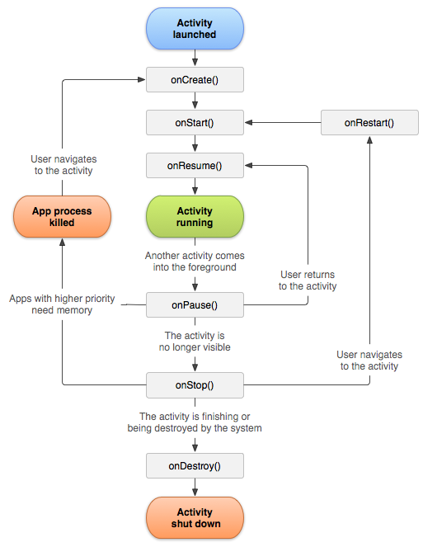
You must implement this callback, which fires when the system first creates the activity. On activity creation, the activity enters the Created state. In the Oncreate() method, you perform basic application startup logic that should happen only once for the entire life of the activity. For example, your implementation of OnCreate() might bind data to lists, associate the activity with a view Model and instantiate some class-scope variables. This method receives the parameter savedInstanceState, which is a bundle object containing the activity's previously saved state. If the activity has never existed before

OnStart ():

When the activity enters the Started state, the system invokes this callback. The OnStart () call makes the activity visible to the user, as the app prepares for the activity to enter the foreground and become interactive. For example, this method is where the app initializes the code that maintains the UI.
When the activity moves to the started state, any lifecycle-aware component tied to the activity's lifecycle will receive the OnStart ()event.
The OnStart ()method completes very quickly and, as with the Created state, the activity does not stay resident in the Started state. Once this callback finishes, the activity enters the Resumed state, and the system invokes the OnResume () method.
OnResume ():

When the activity enters the Resumed state, it comes to the foreground, and then the system invokes the OnResume (): callback. This is the state in which the app interacts with the user. The app stays in this state until something happens to take focus away from the app. Such an event might be, for instance, receiving a phone call, the user’s navigating to another activity, or the device screen’s turning off.
When the activity moves to the resumed state, any lifecycle-aware component tied to the activity's lifecycle will receive the OnResume event. This is where the lifecycle components can enable any functionality that needs to run while the component is visible and in the foreground, such as starting a camera preview.
When an interruptive event occurs, the activity enters the Paused state, and the system invokes the OnPause() callback.

- Important NOTE:
If an activity is in the foreground, and the user taps the Back button, the activity transitions through theonPause(), onStop(), and onDestroy() callbacks. In addition to being destroyed, the activity is also removed from the back stack.
It is important to note that, by default, the onSaveInstanceState() callback does not fire in this case. This behavior is based on the assumption that the user tapped the Back button with no expectation of returning to the same instance of the activity. However, you can override the onBackPressed() method to implement some custom behavior, for example a "confirm-quit" dialog.
If you override the onBackPressed() method, we still highly recommend that you invokesuper.onBackPressed() from your overridden method. Otherwise the Back button behavior may be jarring to the user.

OnPause():
The system calls this method as the first indication that the user is leaving your activity (though it does not always mean the activity is being destroyed); it indicates that the activity is no longer in the foreground (though it may still be visible if the user is in multi-window mode). Use the OnPsause() method to pause or adjust operations that should not continue (or should continue in moderation) while the Activity is in the Paused state, and that you expect to resume shortly. There are several reasons why an activity may enter this state. For example:
- Some event interrupts app execution, as described in the Onresume() section. This is the most common case.
- In Android 7.0 (API level 24) or higher, multiple apps run in multi-window mode. Because only one of the apps (windows) has focus at any time, the system pauses all of the other apps.
- A new, semi-transparent activity (such as a dialog) opens. As long as the activity is still partially visible but not in focus, it remains paused.

onStop()
When your activity is no longer visible to the user, it has entered the Stopped state, and the system invokes the onStop() callback. This may occur, for example, when a newly launched activity covers the entire screen. The system may also call onStop() when the activity has finished running, and is about to be terminated.
When the activity moves to the stopped state, any lifecycle-aware component tied to the activity's lifecycle will receive the ON_STOP event. This is where the lifecycle components can stop any functionality that does not need to run while the component is not visible on the screen.
In the onStop() method, the app should release or adjust resources that are not needed while the app is not visible to the user. For example, your app might pause animations or switch from fine-grained to coarse-grained location updates. Using onStop() instead of onPause() ensures that UI-related work continues, even when the user is viewing your activity in multi-window mode.

onDestroy()
onDestroy() is called before the activity is destroyed. The system invokes this callback either because:
- the activity is finishing (due to the user completely dismissing the activity or due to finish()being called on the activity), or
- the system is temporarily destroying the activity due to a configuration change (such as device rotation or multi-window mode)
When the activity moves to the destroyed state, any lifecycle-aware component tied to the activity's lifecycle will receive the ON_DESTROY event. This is where the lifecycle components can clean up anything it needs to before the Activity is destroyed.
Instead of putting logic in your Activity to determine why it is being destroyed you should use a ViewModel object to contain the relevant view data for your Activity. If the Activity is going to be recreated due to a configuration change the ViewModel does not have to do anything since it will be preserved and given to the next Activity instance. If the Activity is not going to be recreated then the ViewModel will have the onCleared() method called where it can clean up any data it needs to before being destroyed.

- Android Activity Life_cycle Example :
package com.example.rahul.lifecycle.feature;
import android.support.v7.app.AppCompatActivity;
import android.os.Bundle;
import android.util.Log;
import android.widget.Toast;
public class MainActivity extends AppCompatActivity {
@Override
protected void onCreate(Bundle savedInstanceState) {
super.onCreate(savedInstanceState);
setContentView(R.layout.activity_main);
Log.d ("lifeCycle","OnCreate() invoked");
Toast.makeText(MainActivity.this,"Oncreate invoked",Toast.LENGTH_LONG).show();
}
@Override
protected void onStart() {
super.onStart();
Log.d("lifecycle","onStart invoked");
Toast.makeText(MainActivity.this,"onStart invoked",Toast.LENGTH_LONG).show();
}
@Override
protected void onResume() {
super.onResume();
Log.d("lifecycle","onResume invoked");
Toast.makeText(MainActivity.this,"onResume invoked",Toast.LENGTH_LONG).show();
}
@Override
protected void onPause() {
super.onPause();
Log.d("lifecycle","onPause invoked");
Toast.makeText(MainActivity.this,"onPause invoked",Toast.LENGTH_LONG).show();
}
@Override
protected void onStop() {
super.onStop();
Log.d("lifecycle","onStop invoked");
Toast.makeText(MainActivity.this,"onStop invoked",Toast.LENGTH_LONG).show();
}
@Override
protected void onRestart() {
super.onRestart();
Log.d("lifecycle","onRestart invoked");
Toast.makeText(MainActivity.this,"onRestart invoked",Toast.LENGTH_LONG).show();
}
@Override
protected void onDestroy() {
super.onDestroy();
Log.d("lifecycle","onDestroy invoked");
Toast.makeText(MainActivity.this,"onDestroy invoked",Toast.LENGTH_LONG).show();
}
}

Example Of Broadcasts Receiver :

Java Code : main_activity.
package com.example.rahul.broadcasts_headset;
import android.content.BroadcastReceiver;
import android.content.Context;
import android.content.Intent;
import android.content.IntentFilter;
import android.support.v7.app.AppCompatActivity;
import android.os.Bundle;
import android.util.Log;
import android.widget.Toast;
public class MainActivity extends AppCompatActivity {
private static final String TAG = "MainActivity";
private MusicIntentReceiver myReceiver;
@Override
protected void onCreate(Bundle savedInstanceState) {
super.onCreate(savedInstanceState);
setContentView(R.layout.activity_main);
myReceiver = new MusicIntentReceiver();
}
@Override
public void onResume() {
IntentFilter filter = new IntentFilter(Intent.ACTION_HEADSET_PLUG);
registerReceiver(myReceiver, filter);
super.onResume();
}
private class MusicIntentReceiver extends BroadcastReceiver {
@Override
public void onReceive(Context context, Intent intent) {
if (intent.getAction().equals(Intent.ACTION_HEADSET_PLUG)) {
int state = intent.getIntExtra("state", -1);
switch (state) {
case 0:
Log.d(TAG, "Headset is unplugged");
Toast.makeText(MainActivity.this,"Headset is unplugged",Toast.LENGTH_LONG).show();
break;
case 1:
Log.d(TAG, "Headset is plugged");
Toast.makeText(MainActivity.this,"Headset is plugged",Toast.LENGTH_LONG).show();
break;
default:
Log.d(TAG, "I have no idea what the headset state is");
Toast.makeText(MainActivity.this,"I have no idea what the headset state is",Toast.LENGTH_LONG).show();
}
}
}
}
@Override
public void onPause() {
unregisterReceiver(myReceiver);
super.onPause();
}
}

Manifest:
<?xml version="1.0" encoding="utf-8"?>
<manifest xmlns:android="http://schemas.android.com/apk/res/android"
package="com.example.rahul.broadcasts_headset">
<application
android:allowBackup="true"
android:icon="@mipmap/ic_launcher"
android:label="@string/app_name"
android:roundIcon="@mipmap/ic_launcher_round"
android:supportsRtl="true"
android:theme="@style/AppTheme">
<activity android:name=".MainActivity">
<intent-filter>
<action android:name="android.intent.action.MAIN" />
<added android:name="android.intent.action.ACTION_HEADSET_PLUG"/> // Here Added the manifest permission for android headset broadcast receiver.

<category android:name="android.intent.category.LAUNCHER" />
</intent-filter>
</activity>
</application>
</manifest>

